Yarn
# Source: AI Source: Provided by: [Data Path: Persons Table -> ID Column: 1, Name_En Column: Motasem Essam] -> From: [ChatGPT] on [1/26/2026]
Yarn is a dependency manager for JavaScript projects.
It is used to install, update, and manage the libraries (dependencies) your Node.js project needs. Yarn is an alternative to npm, but focuses on speed, reliability, and deterministic installs.

Key Features of Yarn
# Source: AI Source: Provided by: [Data Path: Persons Table -> ID Column: 1, Name_En Column: Motasem Essam] -> From: [ChatGPT] on [1/26/2026]
- Installs project dependencies listed in package.json
- Creates a lock file (yarn.lock) to ensure the same versions are installed on every machine
- Can run scripts defined in package.json
- Supports workspaces for managing multiple packages in one repository

Common Yarn Commands
# Source: AI Source: Provided by: [Data Path: Persons Table -> ID Column: 1, Name_En Column: Motasem Essam] -> From: [ChatGPT] on [1/26/2026]
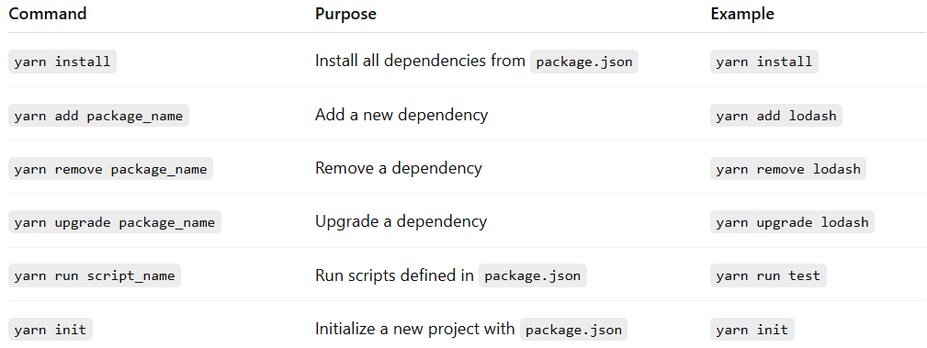
Command | Purpose | Example
yarn install | Install all dependencies from package.json | yarn install
yarn add package_name | Add a new dependency | yarn add lodash
yarn remove package_name | Remove a dependency | yarn remove lodash
yarn upgrade package_name | Upgrade a dependency | yarn upgrade lodash
yarn run script_name | Run scripts defined in package.json | yarn run test
yarn init | Initialize a new project with package.json | yarn init

Example
# Source: AI Source: Provided by: [Data Path: Persons Table -> ID Column: 1, Name_En Column: Motasem Essam] -> From: [ChatGPT] on [1/26/2026]
Install lodash in a Node.js project:
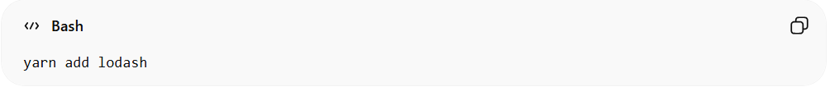
yarn add lodash
Run tests (if defined in package.json):
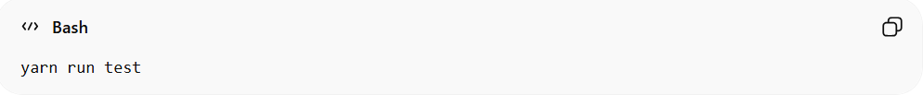
yarn run test

package.json and yarn.lock

package.json
# Source: AI Source: Provided by: [Data Path: Persons Table -> ID Column: 1, Name_En Column: Motasem Essam] -> From: [ChatGPT] on [1/26/2026]
- Purpose: The main manifest file of your Node.js project.
- Contents:
  - Project metadata: name, version, description
  - Scripts: commands you can run via yarn run ...
  - Dependencies: libraries your project needs
  - DevDependencies: libraries needed only for development (tests, linters, etc.)
- Example:
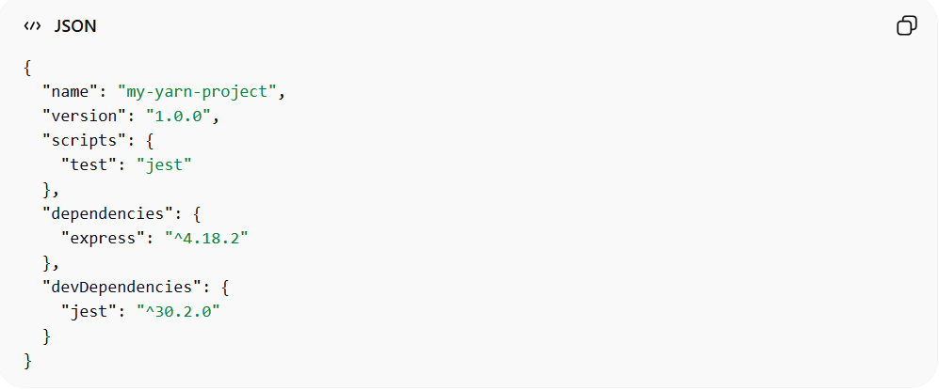
{
"name": "my-yarn-project",
"version": "1.0.0",
"scripts": {
"test": "jest"
},
"dependencies": {
"express": "^4.18.2"
},
"devDependencies": {
"jest": "^30.2.0"
}
}
Think of package.json as the “recipe” for your project — it tells yarn what dependencies to install and which scripts to run.

yarn.lock
# Source: AI Source: Provided by: [Data Path: Persons Table -> ID Column: 1, Name_En Column: Motasem Essam] -> From: [ChatGPT] on [1/26/2026]
- Purpose: Locks the exact versions of all installed dependencies, including nested ones.
- Automatically generated: When you run yarn install
- Ensures: All developers working on the project get the same versions, avoiding “it works on my machine” problems.
- Important: Always commit yarn.lock to version control.
- Example snippet of yarn.lock:
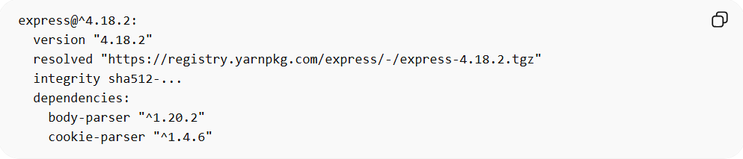
express@^4.18.2:
version "4.18.2"
resolved "https://registry.yarnpkg.com/express/-/express-4.18.2.tgz"
integrity sha512-...
dependencies:
body-parser "^1.20.2"
cookie-parser "^1.4.6"
This works like npm’s package-lock.json, but is specific to yarn.

Summary
# Source: AI Source: Provided by: [Data Path: Persons Table -> ID Column: 1, Name_En Column: Motasem Essam] -> From: [ChatGPT] on [1/26/2026]
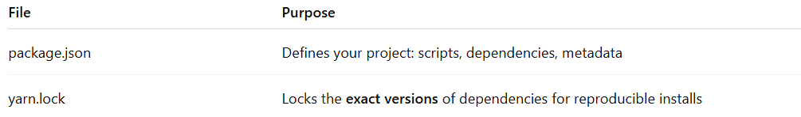
File | Purpose
package.json | Defines your project: scripts, dependencies, metadata
yarn.lock | Locks the exact versions of dependencies for reproducible installs
package.json = what your project needs
yarn.lock = exact versions actually installed

If you want, I can also make a diagram showing how package.json and yarn.lock work together in yarn, which makes it very easy to remember.
Do you want me to do that?

yarn vs npm

1️⃣ Overview
# Source: AI Source: Provided by: [Data Path: Persons Table -> ID Column: 1, Name_En Column: Motasem Essam] -> From: [ChatGPT] on [1/26/2026]
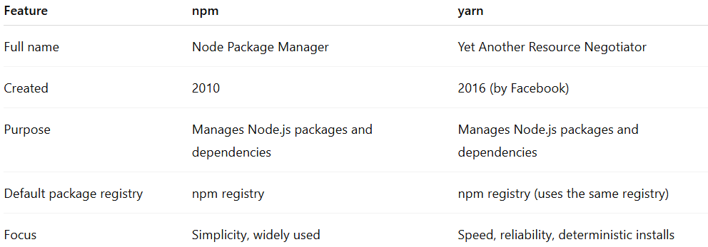
Feature | npm | yarn
Full name | Node Package Manager | Yet Another Resource Negotiator
Created | 2010 | 2016 (by Facebook)
Purpose | Manages Node.js packages and dependencies | Manages Node.js packages and dependencies
Default package registry | npm registry | npm registry (uses the same registry)
Focus | Simplicity, widely used | Speed, reliability, deterministic installs

2️⃣ Installation
# Source: AI Source: Provided by: [Data Path: Persons Table -> ID Column: 1, Name_En Column: Motasem Essam] -> From: [ChatGPT] on [1/26/2026]
- npm comes preinstalled with Node.js
- yarn must be installed separately:
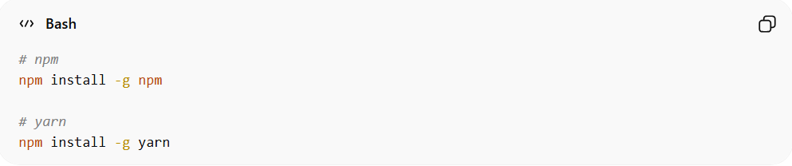
# npm
npm install -g npm

# yarn
npm install -g yarn

3️⃣ Key Features
# Source: AI Source: Provided by: [Data Path: Persons Table -> ID Column: 1, Name_En Column: Motasem Essam] -> From: [ChatGPT] on [1/26/2026]
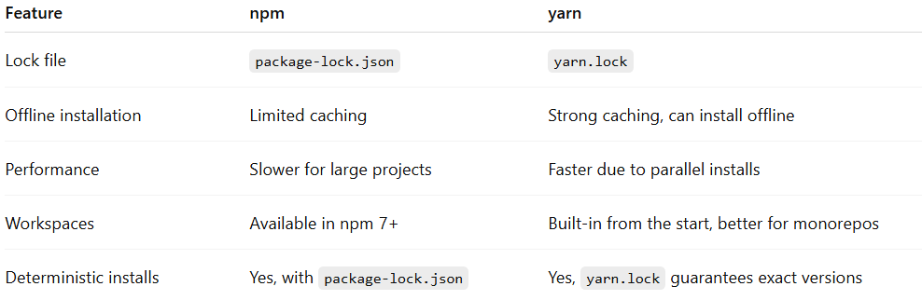
Feature | npm | yarn
Lock file | package-lock.json | yarn.lock
Offline installation | Limited caching | Strong caching, can install offline
Performance | Slower for large projects | Faster due to parallel installs
Workspaces | Available in npm 7+ | Built-in from the start, better for monorepos
Deterministic installs | Yes, with package-lock.json | Yes, yarn.lock guarantees exact versions

4️⃣ Common Commands Comparison
# Source: AI Source: Provided by: [Data Path: Persons Table -> ID Column: 1, Name_En Column: Motasem Essam] -> From: [ChatGPT] on [1/26/2026]
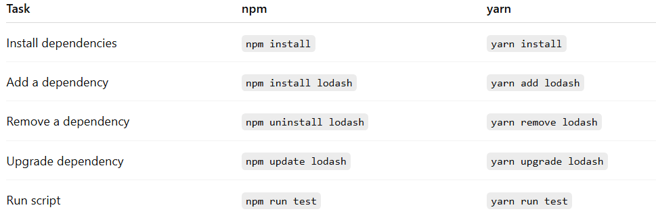
Task | npm | yarn
Install dependencies | npm install | yarn install
Add a dependency | npm install lodash | yarn add lodash
Remove a dependency | npm uninstall lodash | yarn remove lodash
Upgrade dependency | npm update lodash | yarn upgrade lodash
Run script | npm run test | yarn run test

5️⃣ Summary
# Source: AI Source: Provided by: [Data Path: Persons Table -> ID Column: 1, Name_En Column: Motasem Essam] -> From: [ChatGPT] on [1/26/2026]
- Both npm and yarn manage Node.js dependencies and use the same registry.
- yarn is generally faster, more reliable, and better for large projects or monorepos.
- npm is simpler, widely supported, and comes preinstalled with Node.js.

✅ Summary
# Source: AI Source: Provided by: [Data Path: Persons Table -> ID Column: 1, Name_En Column: Motasem Essam] -> From: [ChatGPT] on [1/26/2026]
- Yarn = dependency manager for JavaScript/Node.js projects
- Focuses on project-level libraries, not system software
- Ensures consistent installs across different machines

